Mathematics: Units 3A and 3B
Formula Sheet

Number and algebra

Index laws: For 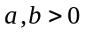and m ,n real,
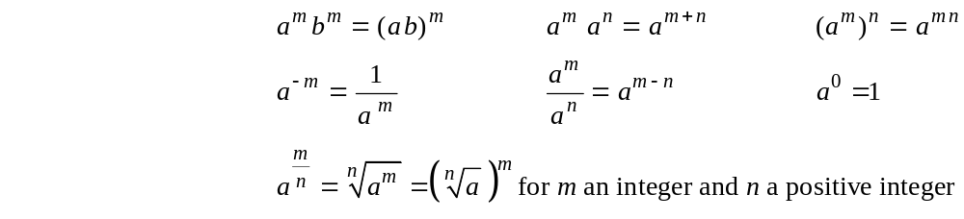

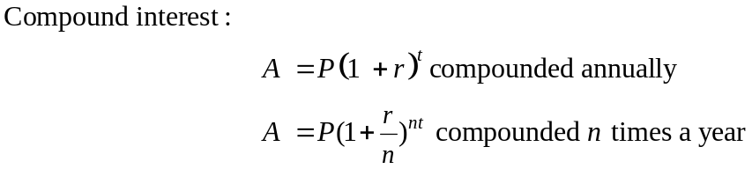
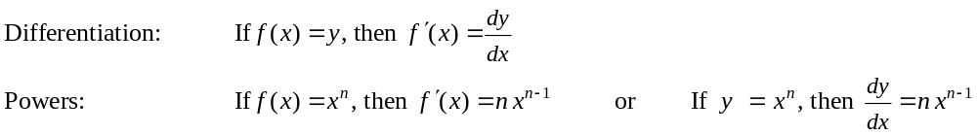

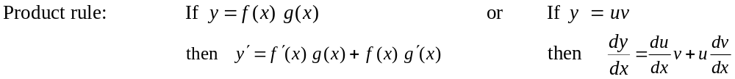

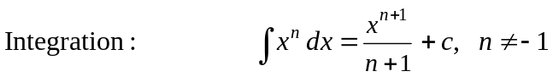
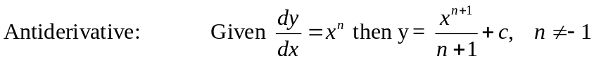

Space and measurement

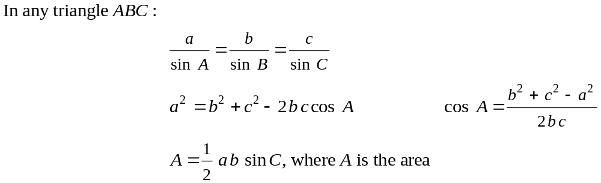

Space and measurement

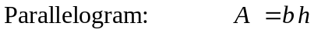
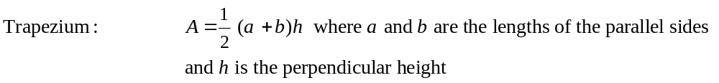
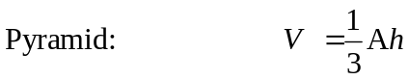
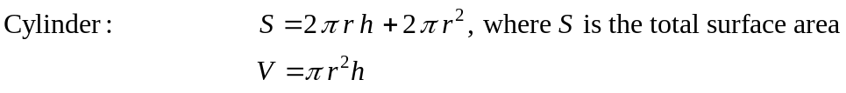
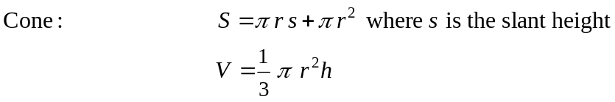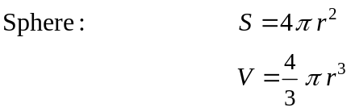

Chance and data

In a normal distribution approximately:
68% of values lie within one (1) standard deviation of the mean
95% of values lie within two (2) standard deviations of the mean
99.7% of values lie within three (3) standard deviations of the mean.

Note: Any additional formulas identified by the examination panel as necessary will be included in the body of the particular question.

